Torrington Early Childhood Collaborative – TECC
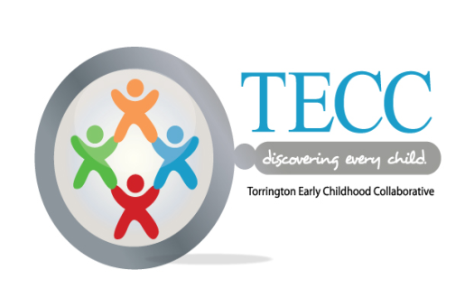
Education Workgroup Agenda
February 13, 2017
12:00 – 2:00
355 Migeon Avenue
DESIRED OUTCOMES:
- Share information on Sc
- School Readiness State and Local Initiatives
- Summer Learning –Share update on summer initiative
- Kindergarten Readiness Fair & Next Steps/Set Workgroup Initiatives

ITEM | LEAD | NEXT STEPS | BY WHOM | PRE-WORK | Time
Introductions/Welcome | TECC Co-Chairs  Tim Waldron, Mayor’s Designee/Mayoral Aide  Sue Fergusson – Superintendents’ Designee/East Principal |  |  | Review Minutes | 12:00
School Readiness  - Income Verification Policy  - Role of the Council | Donna Labbe, School Readiness Liaison/TECC Community Outreach Coordinator
Summer Passport to Reading Results/Next Steps  Fund Development Status  Ready4K App. | Paula Gajewski |  |  |  | 12:15
Kindergarten Readiness Fair –  March 25th  April 1st (Snow Date)  K Fair Station Review  Kindergarten Registration:  March 27-31  April 3-7 | Donna Labbe
+/Δ | Volunteer |  |  |  | 1:55
Next Meeting
March 13, 2017
12:00-2:00 355 Migeon Avenue
Result Statement:
All of Torrington’s children from birth through third grade are healthy and successful learners.

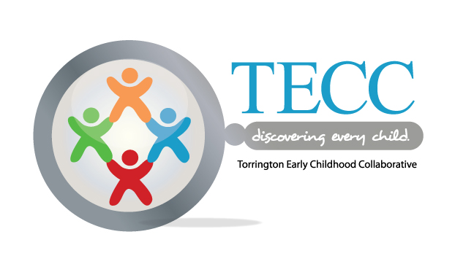

Torrington Early Childhood Collaborative –
Education Workgroup 2016-2017 Meeting Schedule
355 Migeon Avenue

Second Monday of the Month (except where noted * due to school day off)
12:00-2:00 p.m.
2016-2017
- Sept. 12
- *Oct. 17
- Nov. 14
Dec 12 Cancelled
- Jan 9
Feb 13
March 13
*April 17
May 8
**June 5 (first Monday)
**(last meeting of school year – approve calendar for 2016-17)

